CS 255 System Design Document Template

This template lays out all the different sections that you need to complete for Project Two. Each section has guidance to prompt your thinking. You will need to continually reference the interview transcript as you work to make sure that you are addressing your client’s needs. There is no required length for the final document. Instead the goal is to complete each section based on what your client’s needs are. Remove this note when you are finished, and replace all bracketed text with the relevant information.

UML Diagrams

UML Use Case Diagram
[In Module Six, you were asked to complete a use case diagram based on your system design. If you would like to make any adjustments to your diagram, please do so. Please insert your use case diagram here. Check to make sure that you included appropriate components and symbols and that your design meets the client’s needs.]

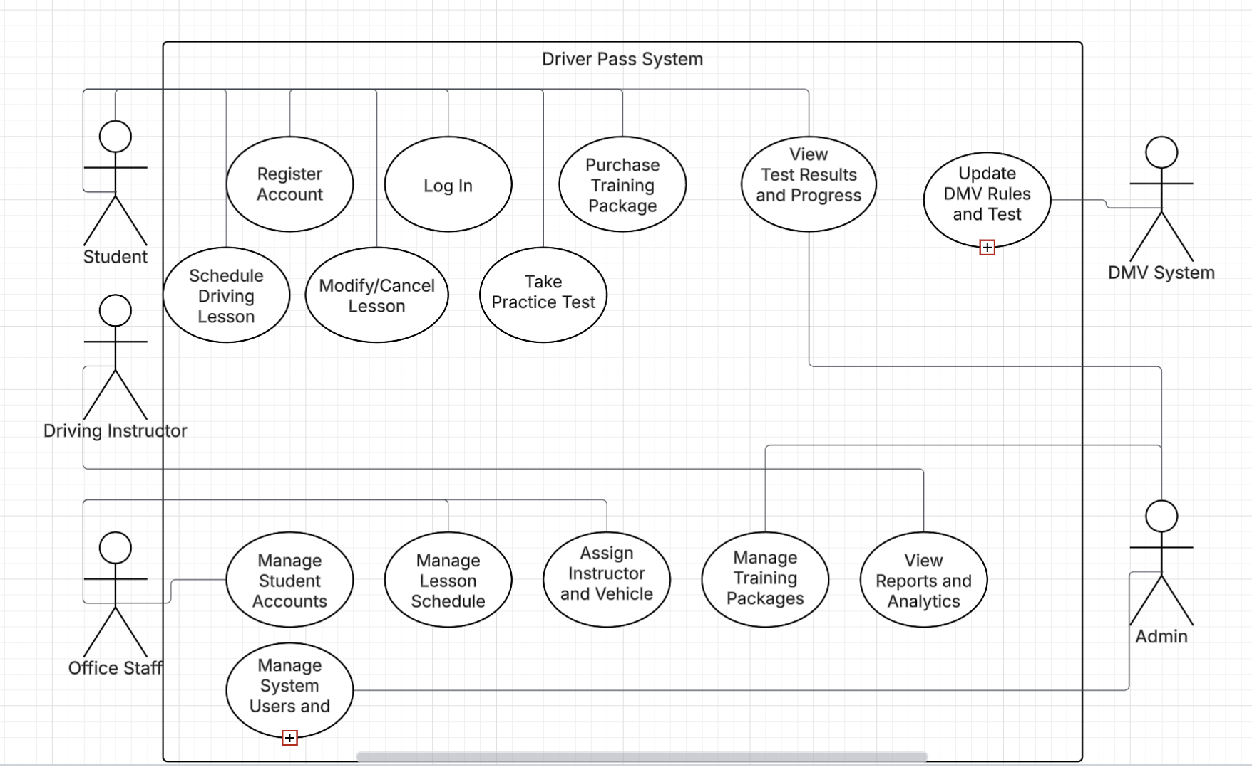

UML Activity Diagrams
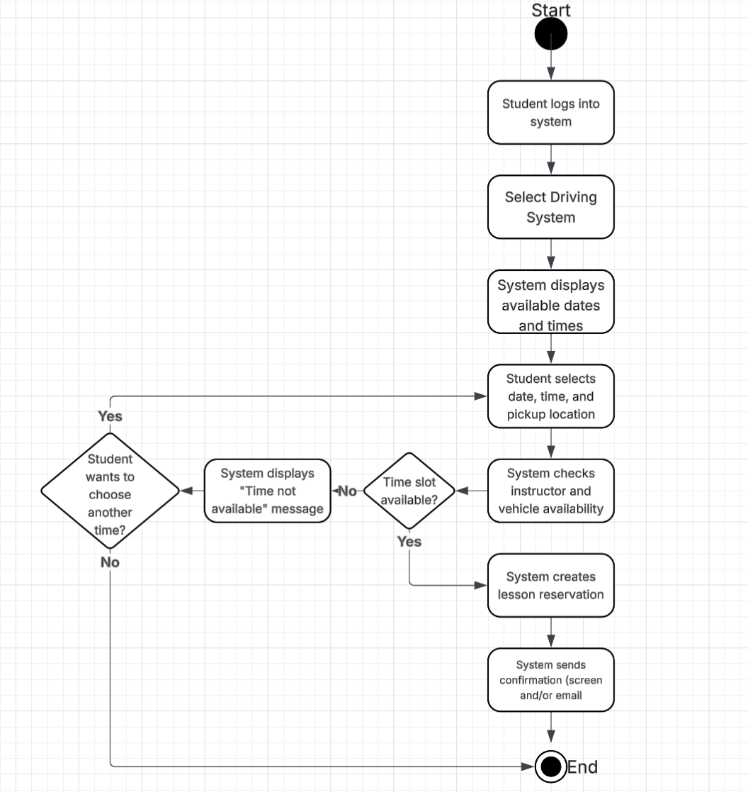

UML Sequence Diagram
[You were asked to create a sequence diagram based on one of the use cases you chose. Please insert your sequence diagram here. Check to make sure that you included appropriate components and symbols and that your design meets the client’s needs.]

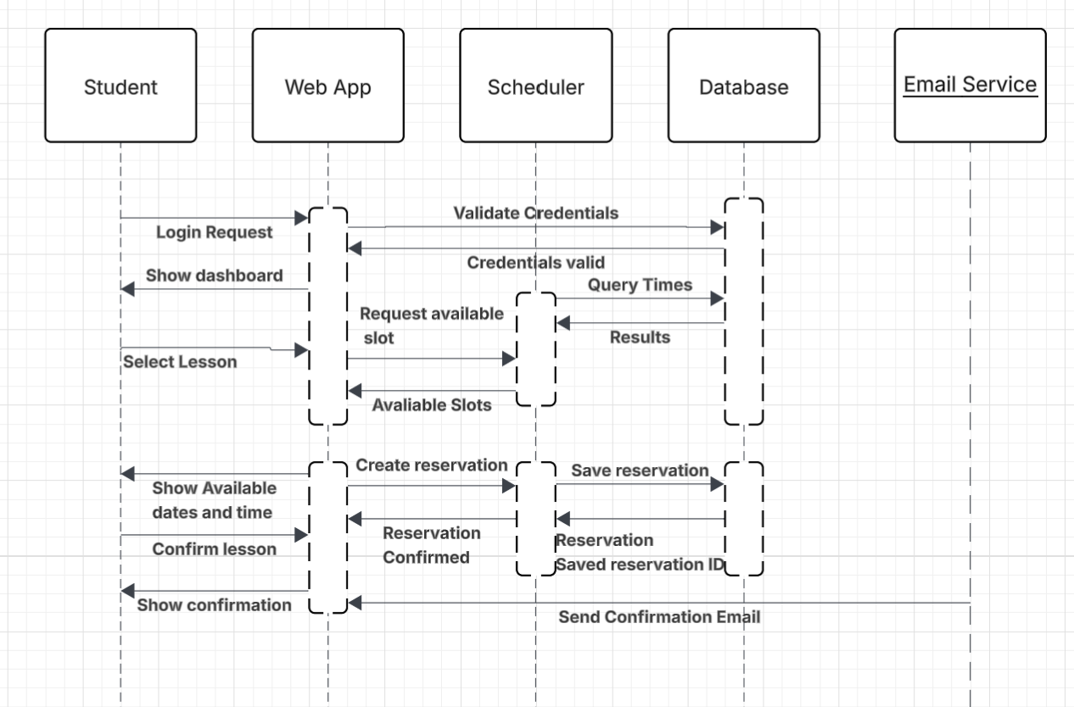

UML Class Diagram
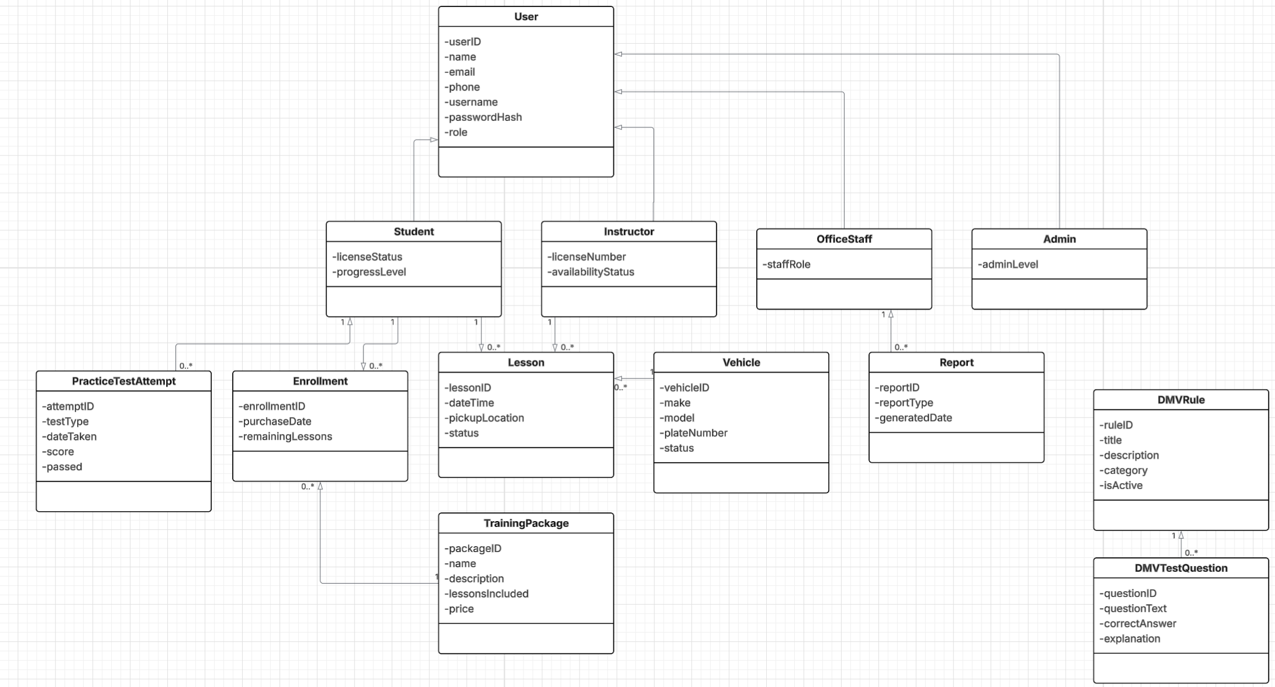

Technical Requirements

The DriverPass System will be implemented as a web-based application to allow students, instructors, office staff, and administrators to access the system from standard desktop or mobile devices with an internet connection. End users will require a modern web browser such as Google Chrome, Microsoft Edge, or Safari. No specialized hardware is required beyond standard computing devices. The system will be hosted on a centralized server or cloud-based environment to ensure availability, scalability, and secure access for all users.
The software environment will include a web application layer responsible for user authentication, scheduling, lesson management, practice testing, and report generation. A relational database will be used to store user accounts, lessons, vehicles, training packages, enrollments, DMV rules, and test results. The system will implement secure authentication using encrypted password storage and role-based access control to ensure users can only access features appropriate to their role. Integration with an email service will be required to send automated confirmations and notifications for scheduled lessons and account activity.
The system infrastructure must support reliable scheduling operations by coordinating instructor and vehicle availability in real time. Administrative users will require tools to manage users, training packages, reports, and DMV rule updates. The system must also support regular data backups and basic fault tolerance to protect user data. These technical requirements ensure the DriverPass System can operate securely, efficiently, and reliably while meeting the functional needs demonstrated in the UML diagrams.

